Water Pump$

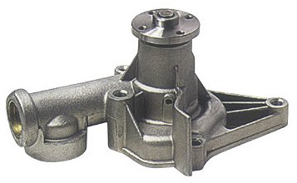
You’re working in Operations for a company that is an important provider of automotive water pumps to a principal auto and truck manufacturer in the United States. Your company makes water pumps of one basic design that goes on two different engine models made by your customer firm. The customer in turn puts those engines in four different models of auto and small trucks.
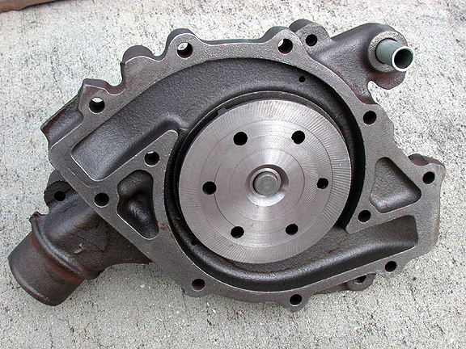
Automobile water pumps are fairly simple devices with only a few moving parts. The major component is the water pump housing, which is designed to hold those moving parts, bolt onto the car’s engine, and attach to coolant hoses. A rough housing is first cast from aluminum in your company’s Casting Department. Then, when cool, the housing is machined (or milled) to much finer tolerances. It is this machining process that is of concern.

For planning purposes, your firm operates 250 days per year and applies a general annual inventory holding cost rate of 27% of item value. It is company policy to manage all inventories to a 99.7% service level.

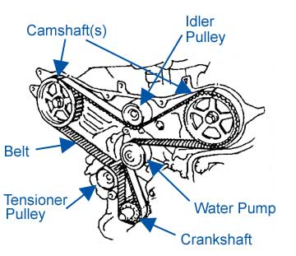
After looking at company data on demand you determine model 795GTX is by far the highest volume pump your company produces. Machining of raw castings of pump housings is now done on an old CNC machine that requires extensive and uncertain setup and preparation because the machine is based on obsolete technology and has difficulty holding tolerances. The raw pump housing, before machining, has a manufactured cost to your company of $16.35 per unit. When working properly, machining the housing adds $5.98 per unit to that value, making the final value of the machined housing $22.33. When operating, the current CNC machine can mill 275 housings per day. Setting up the machine each time a batch of 795GTX housings is to be machined is expensive owing to the specialized labor and long setup times. That cost per setup is estimated to be $3,000.

Engineers tell you a new machine can be purchased to replace the existing equipment. The new equipment could machine 450 housings per day at an estimated cost of $5.75 per unit. Setups should only cost $500 on this machine. Further, it’s estimated that setups should take an average of 2 days to complete with a standard deviation of.1 days.

The product designers and purchasing agents tell you an outside contractor can machine the 795GTX housings. In this scenario your company would still make the rough cast at a cost of $16.35, but then send the rough housing to the contractor for machining. The contractor already does similar work for your company on other water pump models, though taking on a 795GTX contract would represent a significant increase in volumes for them. After being contacted the contractor gave general costing and lead time information. They would charge your firm $7.00 to machine a 795GTX housing, which includes transportation to and from their facility. Further, they would offer a 1.25% discount per unit on all batches of 5000 units or more. The fixed cost of interacting with this vendor on each order is estimated to be $300.

Your initial research shows four different options for machining 795GTX pump housings. These are:
1) continued use of the current equipment,
2) purchasing new equipment,
3) outsourcing the task to the vendor at $7.00 per unit, and
4) outsourcing to the vendor in larger quantities for the 1.25% discount.

Further, you’ve pulled past data on:

1) 150 recent days of demand for 795GTX housings,
2) days for the last 19 setups on the current machine for 795 GTX housings, and
3) days required for the subcontractor to machine and return 25 batches of other pump model housings.

This data is in the embedded spreadsheet at right.

Using this, other information presented here, and what you know about inventory analysis, answer the following questions:

- Which of the four options would result in the lowest total annual cost for machining and inventorying 795GTX water pump housings?
- What are three critical failings of your analysis which prevent you from making a clear recommendation as to which of the four options is best for your firm?

Instructions: Your deliverable will be a functioning Excel, uploaded to Canvas by the assignment deadline stated on the Lesson Plan. Include a cover page for your file which lists your name and the names of any other group members deserving credit for this work. Group sizes may be no larger than 4, and only one group member need submit the final deliverable.

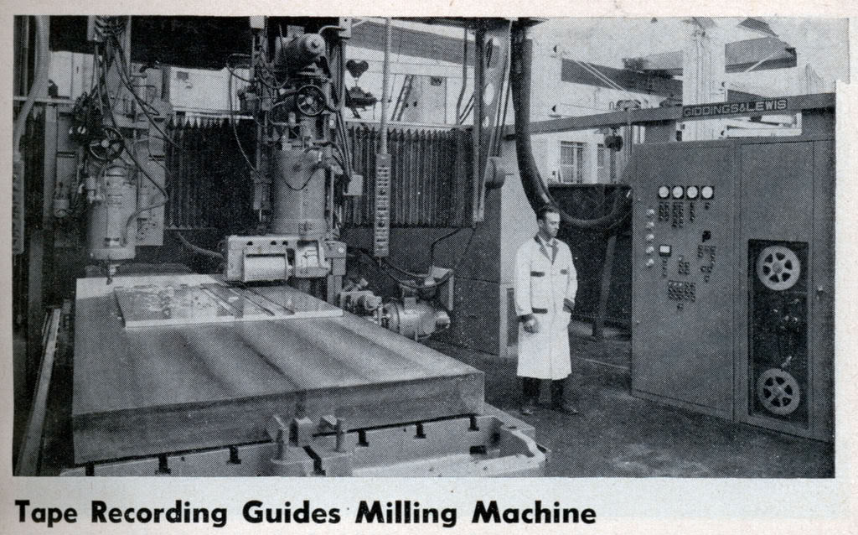

Your Current CNC Machine

